PM-KISAN
INSTRUCTIONS FOR INITIATING THE REFUND MECHANISM IN THE PORTAL

Login
Go to Reports Payment to be recovered from ineligible farmers .

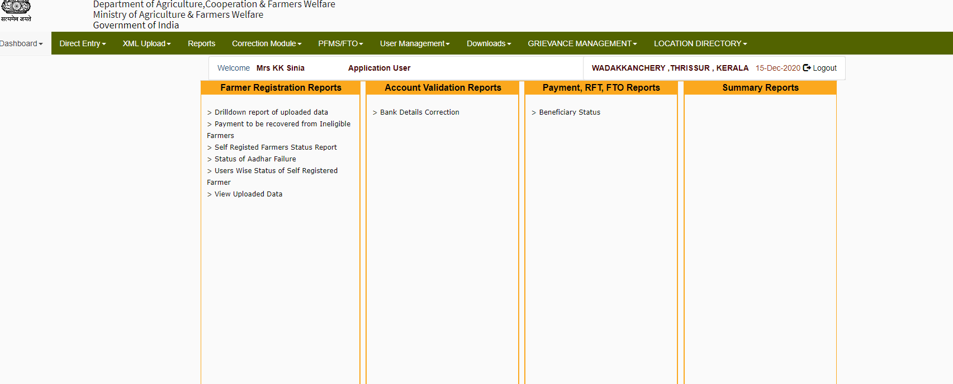

Select the options- ineligible or income tax payees - as per requirement.

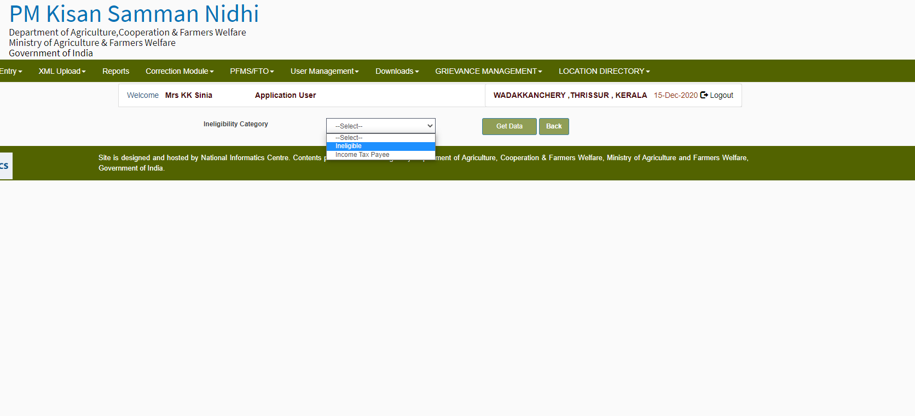

Click “Get data”. Then Block wise report is displayed.
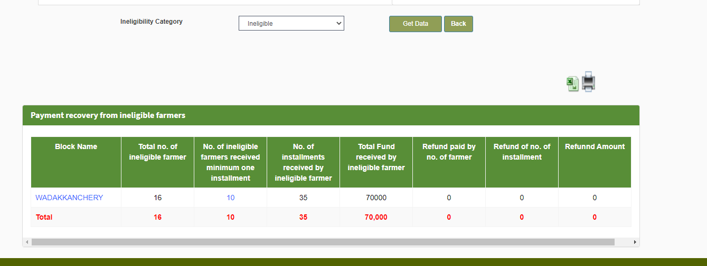
If you click the blue colored number (which is highlighted), an excel sheet of the block wise information of these ineligible persons will be downloaded.
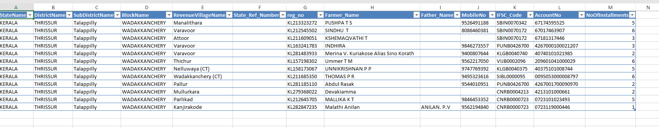
If you click the block name highlighted the drill down details of the villages under the block will be displayed.
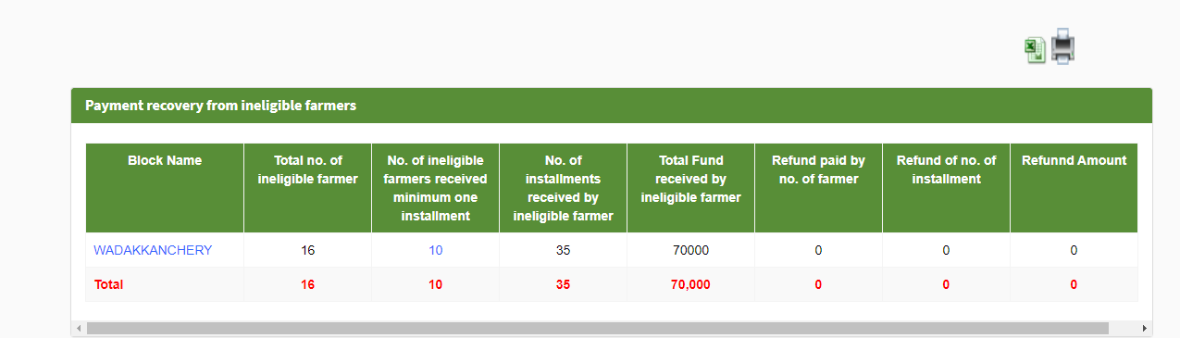

Villages drilled down are displayed below.
Click on village name.
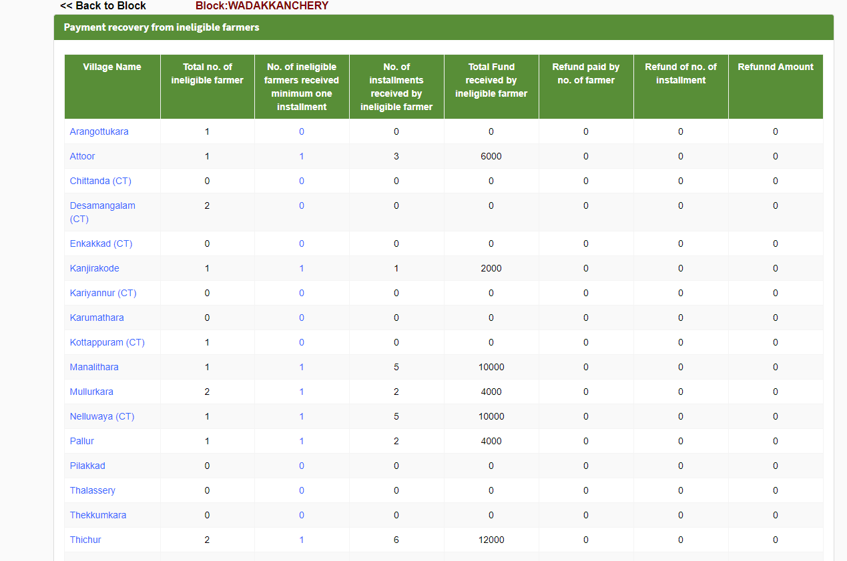

Complete the refund to the specified bank account (A/C No. SBI, Vikas Bhavan Branch, Thriuvnanthapuram IFSC Code: SBIN0070415) and complete Register entry and proceed to online entry of details.

Click “Go for refund”. (under Link for Refund)
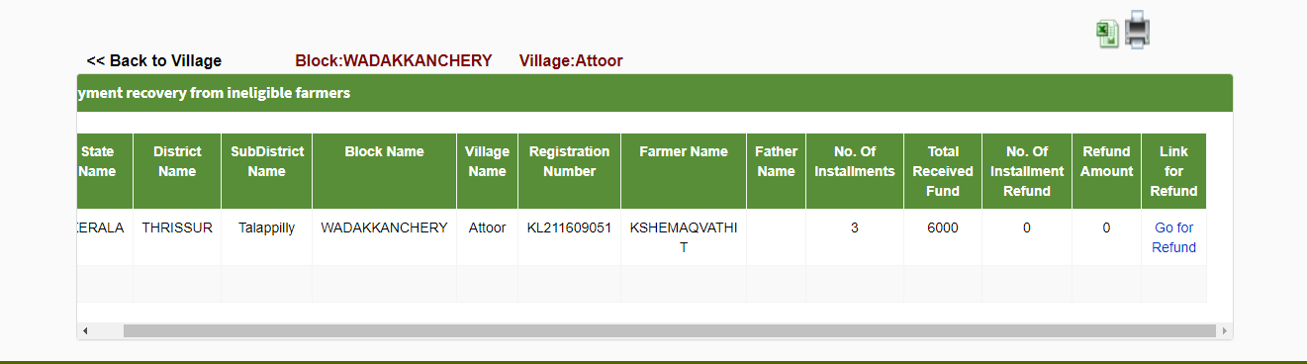

Payment Refund Form A will be displayed.
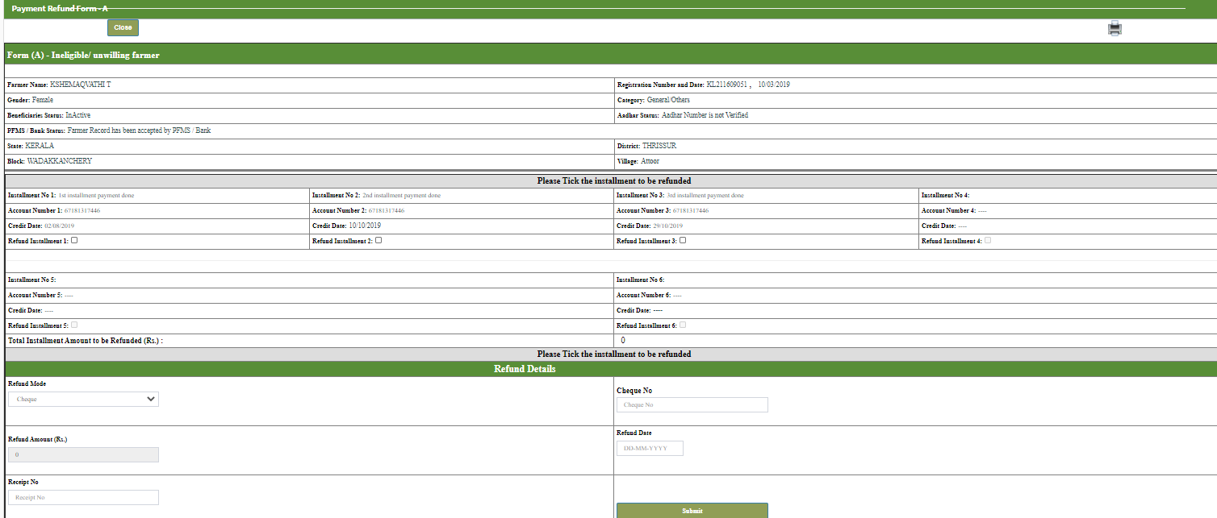

Enter the relevant details needed.
As the tick boxes of the refund installment is clicked the Refund amount is automatically added. The system will not permit any excess amount added.
Fill in the columns “Refund mode – Cash/ Cheque ”.
Cheque number can also be entered.
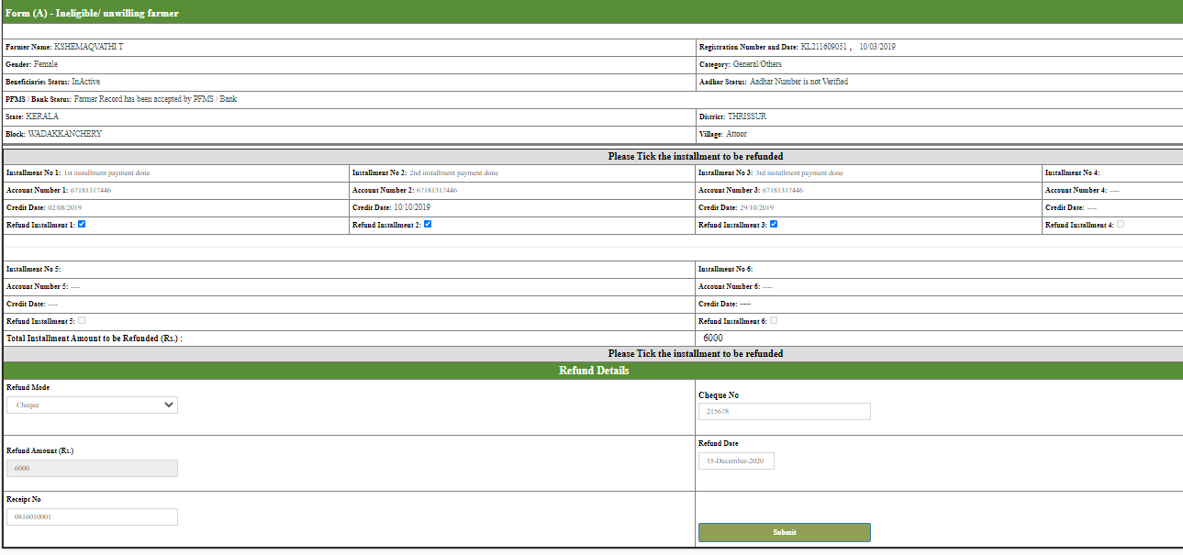

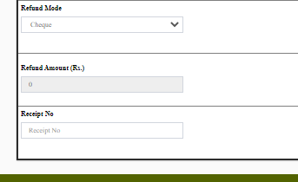
Regarding the receipt number, a code system is envisaged to ensure uniformity and for the systematic tracking of the records entered from the block login. A series of codes have been prepared which shall be shared with all the Principal Agricultural Officers in their official emails.
These district wise code lists shall also be displayed in our official website keralaagriculture.gov.in for ready reference within a few days.
Illustration : Attoor village comes under Desamangalam Krishi Bhavan . So when the official makes the entry of an ineligible farmer in the Receipt number box it will be beginning with 081601XXXX

08 THRISSUR district code
16 Wadakkanchery block code
01 Desamangalam Krishibhavan

A maximum number of ten characters are allowed in this box.
For example: the first entry can be given by Desamangalam KB as the following: 0816010001 and the second entry 0816010002 , third 0816010003 so on.

Maintenance of a PM-KISAN refund register at KB level
A separate register should be maintained for PM-KISAN refund cases. The officer who does the particular entry in the portal shall enter the relevant details in this register with AADHAAR No, Name of the farmer, Category, Gender, Reason for ineligibility (death/ ineligible / income tax payee), total number of installments refunded, Cash/ cheque amount, cheque or DD number, Date, Receipt number ( IN CODE FORMAT ONLY ) , Name of the official making the entry in the portal , Signature of the official, and finally the dated counter sign of Agricultural Officer .
Issue of notice if the ineligible person is unwilling to refund the amount:
A notice can be issued from the Krishi Bhavan on behalf of the State nodal officer to initiate the refund process if the farmer do not voluntarily come forward to make the refund. (A Sample format is attached for information).
Refund report to SPMU
Refund reports in prescribe Excel format (Attached) from Krishi Bhavans should be consolidated by the concerned Assistant Directors of Agriculture and should be submitted to the PAO on the 3rd working day of every month.
The Principal Agricultural Officers are requested to provide the Consolidated District wise refund statement to the PMKISAN State Project Management Unit (SPMU) on the 5th working day of every month in the e-mail ID pmkisanrefund@gmail.com. This mail ID should be exclusively used for sending the monthly refund report. .Krishi Bhavans should not send individual reports directly to Stare PMU unless it is specifically requested.

For State Nodal Officer PMKISAN- Kerala State PMU IT Cell, Directorate of Agriculture
Email : pmkisanrefund@gmail.com
Land line: 0471-2304022

